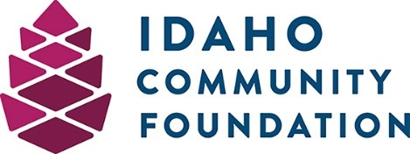
Junior Garnier and Bud Ashford Military Veterans Fund Application
DEADLINE: May 1st

Organization and Contact Information

Organization Name:
Mailing Address:
Contact Person:
Phone:
Email:

Organization Overview
Please state your organization’s mission and/or provide a brief overview of your organization and its primary objectives.

Amount Requested (max. $1,500):

Project Description
Please complete the following sentence:
If my organization is awarded a grant, the funds will be used to… (please limit to one sentence)

Project Narrative
Please describe your project in greater detail, including when the project will occur, how it will be implemented, who is involved, etc.

Project Outcomes
Please describe the outcomes or impact you expect to have with these funds, should they be awarded to your organization. Ex: number of veterans served, etc.

Organization Leadership
Please list the key officers/board members for your organization and their position/title.

Other Grant Funding
Please describe other recent grants you have received from other organizations or units of government. If there are none, you may leave this section blank.

Grant Reporting
If you received a grant from this fund last year, you must submit an End of Grant Report before you will be eligible for more funding. The End of Grant Report for last year’s grant may be submitted at the same time as the application. Please visit grants@idahocf.org for a copy of the end of grant report.

Attachments
Please submit as many of the following documents as possible with your application. Please include a short explanation of any items you cannot provide in the Notes section below.

- Evidence of the legal status of your organization such as organizing documents, articles of incorporation, charter, tax classification or certification from appropriate authorities

- Recent financial statements

- A copy of your latest tax return

Submission Instructions:
Please email this application and required attachments to grants@idahocf.org.

Questions?
For questions related to this grant, or to request a paper copy of this application be mailed to you, please contact grants@idahocf.org or call (208) 342-3535.

